Keith Jhaeron Cayatoc

B.I.T Student

Nelson Marlborough Institute of Technology

WEB701 Assignemnt One

Tutor: Todd Cochrane

YEN-YANG Youth Empowerment

Design, Evaluation and Development

# Executive Summary/ Abstract

Contents

Executive Summary/ Abstract 1

Designing the website. 3

Website Brief 3

What are the Website requirements? (using Information Architecture analysis) 4

Site Goals 4

Define the User experience 4

Site Content 4

Site Structure 5

User Stories – Designing to build 6

CRUD analysis – API prototype 6

Evaluating web technology – which to use.? 7

Developing the website 8

# Introduction

# Designing the website.

## Website Brief

The members of the Yugen organization are interested in having a website of their own. The following is brief description on the proposed website:

|  |
| --- |
| YEN-yang is a “Youth Empowerment Network” charity in the Nelson region who offer their empowerment program to the local community.  We need a website for the Nelson region for members of the charity to provide mentorship, career guidance, and skill-building opportunities to at-risk youth in order to help them realize their potential and achieve their goals.  The purpose of the new website is to help with the establishment and expansion of the youth program by members of our charity to customers. The website lets members register and describe the services they are being provided with, what they gain in joining the program and how did it make an impact with their lives.  The website lets members of the community access the service, by providing tickets that can be “spent” in the service. To achieve our goal, we would like to have an online ticket function on our website that let a beneficiary access a limited number of tokens, for example the system needs a mechanism that verifies that a member of the community is accessing the service and that the ticket belongs to a particular community member. The website needs some homepage text about general information of our services such as: types, characteristics, quality factor, usage and benefit.  The website requires the following features:  1. **User Account -** Charity members and beneficiaries can register, log in and administer their own accounts.  2. **Home Page -** Overview of YEN’s mission, core objectives, and a summary of recent achievements and upcoming events.  3. **Programs Page -** Detailed descriptions of each program (Mentorship, Career Development, Skill-Building, etc.), including how to get involved or apply.  4. **Success Stories -** Testimonials and profiles of individuals who have benefited from YEN’s programs, showcasing their achievements and growth.  5. **Get Involved Page:**  a. **Volunteer Opportunities -** Information on how to become a mentor, workshop facilitator, or volunteer.  -b. **Donation Options -** Ways to contribute financially or through in-kind donations.  c. **Partnerships -** Details on how organizations can partner with YEN to support its mission.  6. **Events Page -** Calendar of upcoming workshops, mentorship meet-ups, and fundraising events.  7. **Resources Page -** Access to educational materials, career planning tools, and links to external resources relevant to youth development.  8. **Blog -** Articles on topics related to youth empowerment, success stories, and tips for personal and professional growth.  9. **Contact Page** - Contact form, social media links, and information for reaching out to the organization for inquiries or support. |

## What are the Website requirements? (using Information Architecture analysis)

### Site Goals

The goal of the website is to provide a platform with a range of resources, programs, and opportunities. By fostering a supportive physical and/or online environment, we strive to empower the next generation to take charge of their futures and make a positive impact on the world.

#### Mission or purpose of the website.

The mission of the website is to provide mentorship, career guidance, and skill-building development to youths who have limited to no access with proper support and education in order to help them realize their potential, gain additional skills that will benefit not only the individual but also people around them, and achieve their goals.

#### Short and long-term goals.

Short-term goals:

1. Making sure that the website is live, user-friendly and visually appealing are the basics that a website should have. It should include the essential features like information about the program, contact details, and basic resources.
2. Creation of initial content like articles, videos, and success stories related to youth empowerment is expected to be added to the website.
3. Set up social media accounts and link them to the website and start posting regularly to engage with audience making an online presence to drive traffic to the site.
4. Incorporate a system for users to provide feedback about the website and the program, this can include surveys, contact forms, or forums.
5. Establish partnerships with local organizations, schools, or influencers to promote the website and program.

Long-term goals:

1. Continuously add valuable content such as workshops, webinars, toolkits, and case studies. Also consider making specialized sections on topics like mental health or career planning.
2. Plan to integrate interactive features like forums, mentorship matching, or virtual workshops to help engagement and networking among users.
3. Develop a cohesive brand identity and marketing strategy to increase recognition and trust, this includes a consistent visual style, branding materials, and a clear mission statement.
4. Keep the website and content updated with the latest trends and information relevant to youth empowerment to ensure that the program remains useful.

#### Intended audiences (a brief overview)

#### Why will people come to the website?

People will visit this website to access a variety of resources, opportunities, and support specifically designed to help them thrive. Whether they are seeking personal development, exploring educational content, or connecting with a community of like-minded individuals, the website provides a welcoming space for young people to grow and succeed. It serves as a go-to destination for youth looking to overcome challenges, discover new possibilities, and take proactive steps toward a brighter future.

### Define the User experience

One short sentence that introduces the desired experience for users of the website.

#### The Audience

##### First type of audience

**Youth Participants** – Young individuals who will engage with the program directly. They might be looking for opportunities to learn, and develop new skills, or find support for personal growth.

**Characteristics:**

* **Age Range:** 15-25 years old
* **Goals:** Personal development, skill-building, networking, finding mentors
* **Challenges:** Navigating career choices, balancing multiple responsibilities, finding relevant resources

##### Second type of audience.

**Program Organizers –** Individuals or organizations running the youth empowerment program. They are the ones who manage content, events, and communication.

**Characteristics:**

* **Age Range:** 25-45 years old
* **Goals:** Effective management of the program to engage with participants and track progress
* **Challenges:** Ensuring smooth operation of the program in whole

##### Third type of audience.

**Supporters and Mentors –** Volunteers, mentors, and mentors who contribute their time, expertise, and/or resources to the program.

**Characteristics:**

* **Age Range:** 25-65 years old
* **Goals:** Provide guidance, mentoring youth, supports the programs mission
* **Challenges:** Finding suitable mentees, managing time commitment, and tracking interactions

#### Scenarios and Personas

Write 3 to 4 short scenarios that describe how the website is going to be used. Write “grungy” persona descriptions.

|  |  |
| --- | --- |
| **Scenarios** | **Personas** |
| **1. Youth Participant Joining the Program**  Goal: Discover the program, sign up, and get started.  How the website will be used:   * Visit the homepage * Explore the program offerings and benefits * Signup for an account or register for the program * Access introductory resource and guidance   Challenges: Finding relevant information quickly and understanding how to get started. | **Name:** Emma (An aspiring youth leader)  **Age:** 18  **Background:** Highschool senior, involved in school clubs, and looking to build leadership skills.  Emma’s goal is to develop the ability to lead, network with peers and mentors, and find internship opportunities.  **Needs:** Easy access to program resources and a clear sign-up process.  **Pain Points:** Overwhelmed by choices and needing guidance on how to start. |
| **2. Program Organizer Creating a New Event**  Goal:Schedule and manage an event for participants.  How the website will be used:   * Log in to the organizer’s dashboard * Create a new event with details like date, time and description * Publish the event and notify participants * Track registrations and manage event logistics   Challenges: Ensuring accurate information and managing participant engagement. | **Name:** James (The program coordinator)  **Age:** 35  **Background:** Works for a non-profit focusing on youth development also responsible for organizing events and managing content.  James’s goal is to streamline event management, engage with participants effectively and analyze program impact.  **Needs:** User-friendly dashboard, tools for managing events and communications as well as analytics for tracking progress.  **Pain Points:** Complex administrative tasks and having difficulties in tracking management. |

|  |  |
| --- | --- |
| **3. Mentor Connecting with a Mentee**  Goal: Establish and maintain a mentoring relationship.  How the website will be used:   * Log in to the mentor’s dashboard * View mentee profiles and select one to connect with * Schedule a meeting with the mentee * Provide feedback and support through the platform   Challenges: Finding compatible mentees, scheduling sessions, maintaining effective communication. | **Name:** Sarah (An experienced mentor)  **Age:** 45  **Background:** Experienced professional who is looking forward to giving back by mentoring young individuals.  Sarah’s goal is to find and connect with mentees in order to share expertise and track mentoring progress.  **Needs:** Simple connection process, tools for scheduling and communication, feedback mechanisms.  **Pain Points:** Time constraints, finding suitable mentees, and managing communication. |
| **4. Supporter Donating to the Program**  Goal: Contribute financially to support the youth empowerment program.  How the website will be used:   * Visit the website and navigate to the “Get Involved” page * Review different donation options and impacts for example a one-time donation or monthly support * Select a donation amount and provide payment details * Receive a confirmation of the donation and a thank-you pop-up message   Challenges: Ensuring the donation process is secure and straightforward and understanding the impact of their contribution. | **Name:** David (Community Supporter)  **Age:** 50  **Background:** Retired business executive looking to support community initiatives and youth programs.  David’s goal is to see the tangible impact of his donations which will provide meaningful causes and stay informed about the program’s success.  **Needs:** Clear information on how donations are used, an easy and secure donation process, and updates on the programs’ progress.  **Pain Points:** Uncertainty about the effectiveness of his contribution and a complex donation process. |

#### Competitive Analysis

Look for and write about other websites like your one, e.g. charity and goods distribution websites. At least three, best would be five. For each website write about their functional and visual layout. What do they have in them that is useful, and what is not useful? Write a summary of the requirements you have discovered.

1. <DoSomething.org>

**Functional Layout:**

* Offers a wide range of campaigns that users can join to make a social impact.
* Provides a sign-up process that guides users to relevant actions and campaigns based on their interests.
* Features a mobile-friendly design with easy navigation and quick access to key campaigns.

**Visual Layout:**

* The website has a bold, vibrant design with bright colors and large fonts which can be appealing to a younger audience.
* The homepage highlights current campaigns and offers a clear call to action.

**Useful Features:**

* Personalized campaign suggestions based on user preferences.
* A community section where users can share their stories and connect with others.

**Less Useful Features:**

* Some campaign pages have heavy text and lack visual aids, making them less engaging.

**Summary of Requirements:**

* Personalized content recommendations.
* Strong visual identity to appeal to the target audience.
* Community engagement features.

2. <Youth.gov>

**Functional Layout:**

* Serves as a comprehensive resource hub for youth programs, covering a wide range of topics from education to health.
* Offers tools and resources for both youth and professionals working with youth.
* Provides a search function for easy access to specific resources.

**Visual Layout:**

* The design is professional and somewhat formal, with a straightforward layout.
* The website uses a muted color palette and standard fonts, which may not be as engaging for younger users.

**Useful Features:**

* • A well-organized resource library with filters to help users find relevant information.
* Links to grants and funding opportunities for youth programs.

**Less Useful Features:**

* The formal design and text-heavy pages might be less appealing to the younger audience.

**Summary of Requirements:**

* Comprehensive resource library with easy navigation.
* Consideration for a more engaging visual design.

3. [Global Youth Empowerment Fund](https://oyaop.com/opportunity/competitions-and-awards/global-youth-empowerment-fund/)

**Functional Layout:**

* Focuses on providing grants and funding for youth-led initiatives worldwide.
* Includes an application portal for funding requests, with clear guidelines and criteria.
* Offers success stories and case studies of previous projects.

**Visual Layout:**

* The design is clean and professional, with a focus on visuals that showcase youth projects.
* The homepage highlights key initiatives and success stories, with minimal text.

**Useful Features:**

* Easy-to-navigate application process with clear instructions.
* Case studies that provide inspiration and insights for potential applicants.

**Less Useful Features:**

* Limited interactivity or community features, making it more of an informational resource.

**Summary of Requirements:**

* A clear and user-friendly application process.
* Visual storytelling to inspire and engage users.

4. [YouthEmployment.org](https://www.youthemployment.org.uk)

**Functional Layout:**

* Offers resources for youth to improve employability, including a job board and skills development tools.
* Includes a member portal for personalized content and tracking progress.
* Provides a section for employers to connect with young talent.

**Visual Layout:**

* The design is professional with a focus on functionality, using a simple color scheme.
* The layout is straightforward, with a focus on usability and accessibility.

**Useful Features:**

* Personalized member portal that provides content to user needs.
* Job board and employability resources directly integrated into the site.

**Less Useful Features:**

* The visual design is somewhat plain, which might not be as engaging for the younger audience.

**Summary of Requirements:**

* Personalized user experience.
* Integration of job-related resources and tools.

5. [Youth Empowerment](https://plan-international.org/youth-empowerment/)

**Functional Layout:**

* Focuses on advocating for youth rights and gender equality.
* Offers educational resources, campaign information, and opportunities for youth to get involved in advocacy.
* Includes a blog and news section to keep users informed on relevant topics.

**Visual Layout:**

* The design is modern and dynamic, using bright colors and engaging visuals.
* The homepage features large images and videos that highlight key campaigns and issues.

**Useful Features:**

* Strong focus on visual storytelling and multimedia content.
* Opportunities for youth to participate in advocacy and campaigns.

**Less Useful Features:**

* The site can be overwhelming due to the large amount of content presented at once.

**Summary of Requirements:**

* Engaging visual and multimedia content.
* Clear opportunities for user involvement in campaigns and advocacy.

**Overview of the Discovered Requirements**

**Personalized User Experience -** Incorporating features like personalized content recommendations or member portals can greatly enhance user engagement.

**Strong Visual Identity -** A vibrant, modern design that appeals to the target audience is essential. Visual storytelling, including the use of images, videos, and case studies, is highly effective.

**Resource Accessibility –** Clear and well-organized access to resources including tools for personal development, education, and employment which is crucial.

**Engagement and Community Features –** Features that allow for community interaction, such as forums, success stories, and mentorship connections, are highly valued.

### Site Content

#### Content and Functional requirements

Write a summary of the required content of the website and list the Functional requirements.

The YEN-YANG youth empowerment website will serve as a central hub for young individuals seeking personal growth, mentorship, resources, and community involvement. The content should be engaging, informative, and tailored to the needs of various users, including youth, mentors, program coordinators, and community supporters.

**1. Homepage**

* Overview of the program's mission and goals.
* Highlighted opportunities, such as upcoming events, workshops, or campaigns.
* Quick access to registration or sign-up links for different user roles (youth, mentors, volunteers).
* Testimonials or success stories from program participants.

**2. Programs and Initiatives**

* Detailed descriptions of available programs, workshops, and events.
* Information on how to join or participate in different initiatives.
* Success stories and case studies showcasing the impact of past programs.

**3. Resources**

* A library of educational content, including articles, videos, and guides on topics such as leadership, mental health, career development, and community involvement.
* Access to downloadable materials, like worksheets or toolkits.
* Links to external resources or partner organizations that offer additional support.

**4. Mentorship**

* Information about the mentorship program, including how to become a mentor or mentee.
* Profiles of available mentors, highlighting their expertise and areas of focus.
* Tools for scheduling and managing mentorship sessions.

**5. Community Engagement**

* Forums or discussion boards where users can connect, share experiences, and support one another.
* Information on community projects or volunteer opportunities.
* Space for users to share their own stories and experiences.

**6. Events Calendar**

* A calendar listing upcoming events, workshops, webinars, and other program-related activities.
* Registration links and details for each event.
* Recording of past events.

**7. About Us**

* Information about the organization, including its history, mission, and team.
* Contact details and a form for inquiries.
* A section for news or updates related to the program.

**8. Donation and Support**

* Information on how users can support the program through donations or volunteering.
* Clear and secure donation process.
* Acknowledgment of donors and supporters, highlighting their contributions.

**9. User Testimonials**

* Testimonials from past and current participants, mentors, and supporters.
* Success stories showcasing the impact of the program.

**10. Blog or News Section**

* Regularly updated articles, news, and insights related to youth empowerment.
* Guest posts from participants, mentors, or industry experts.

**Functional Requirements**

**1. User Registration and Authentication**

* Ability for users to sign up as youth participants, mentors, or community supporters.
* Secure login system with password recovery options.
* Role-based access to specific content and features.

**2. Personalized Dashboards**

* Dashboards tailored to the user's role, providing quick access to relevant content, upcoming events, and progress tracking.
* Notifications for upcoming events, mentorship sessions, or new resources.

**3. Content Management System (CMS)**

* A CMS for program coordinators to easily update and manage content, such as events, resources, and blog posts.
* Ability to categorize and tag content for easier navigation and searchability.

**4. Mentorship Management Tools**

* Tools for mentors and mentees to connect, schedule sessions, and track progress.
* Integration with calendars and communication platforms (e.g., email, video conferencing).

**5. Event Management System**

* A system for creating, managing, and promoting events.
* Registration forms for events and automatic reminders for participants.
* Integration with calendars and event recap options.

**6. Resource Library**

* A searchable and filterable library of resources.
* Downloadable content and links to external resources.
* Ability for users to bookmark or save resources for later.

**7. Community Forums/Discussion Boards**

* Secure and moderated forums where users can interact, ask questions, and share experiences.
* Categories for different topics of interest, such as leadership, mental health, or community projects.

**8. Donation and Payment Processing**

* A secure system for processing donations, with options for one-time or recurring contributions.
* Integration with payment gateways (e.g., PayPal, Stripe).
* Acknowledgment and receipt generation for donors.

**9. Analytics and Reporting**

* Tools for tracking user engagement, resource usage, and event participation.
* Reporting features for analyzing program impact and making data-driven decisions.

**10. Responsive Design**

* A mobile-friendly design that ensures the website is accessible on all devices.
* Fast loading times and intuitive navigation for a seamless user experience.

**11. Search Functionality**

* A robust search feature that allows users to find content, resources, events, and mentors easily.
* Filters and categories to refine search results.

**12. Feedback Mechanisms**

* Forms for users to provide feedback on the program, resources, or website.
* Tools for collecting and analyzing user feedback to improve the program.

#### Group and Label your Content

### Site Structure

#### Metaphors

Write a brief definitional of:

**Organizational metaphor**

The website is organized like a community hub or town center where various activities and resources are accessible from central locations. Just as a community hub offers different services and spaces for interaction, the website will provide distinct sections like programs, resources, mentorship, and events that users can easily navigate to find what they need. Each section is like a room in this hub, with specific functions and content tailored to different user needs.

**Functional metaphor**

Functionally, the website operates like a toolkit, providing users with the tools they need to achieve their personal and professional development goals. Just as a toolkit contains various instruments for different tasks, the website offers resources, mentorship connections, event management, and community engagement features. Users can "pick up" the tools they need, whether it is accessing a guide, signing up for a workshop, or connecting with a mentor.

**Visual metaphor**

The website will resemble a pathway or journey symbolizing the progression and growth that the users will experience. The design will guide users through a series of steps, with clear markers (like signposts) for key actions, such as registering, finding resources, or joining events. The pathway will be visually represented by clean, intuitive navigation and a layout that naturally leads the user from one section to the next, reflecting the idea of moving forward on their empowerment journey.

#### Site structure listing

Write a text based hierarchical listing of your website. This should come from your Grouping and Labeling work.

**Homepage**

* Welcome to the YEN-YANG Youth Empowerment Program Website

**Youth Programs**

* Programs and Initiatives
* Mentorship

**Support and Engagement**

* Resources
* Community Engagement
* Events Calendar

**Community and Updates**

* User and Testimonials
* Blog/News

**Information and Support**

* About Us
* Donation and Support

#### Architectural “blueprint”

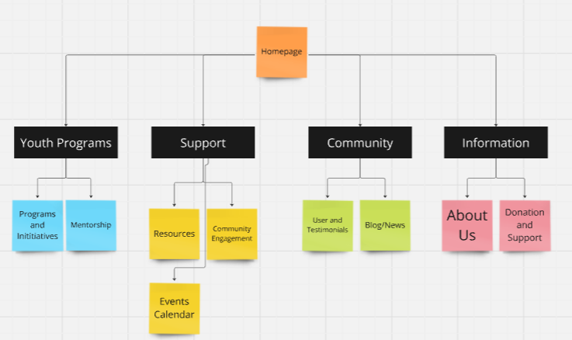

#### Define navigation

#### Visual Design

## User Stories – Designing to build

User Stories for Youth Empowerment Website

As Emma, the Aspiring Youth Leader:

**User Story 1** - As Emma, I want to easily find and sign up for youth programs and initiatives so that I can develop my leadership skills and connect with like-minded peers.

Acceptance Criteria:

* A clear and accessible “Programs and Initiatives” section with a sign-up button.
* A user-friendly form to complete the registration process.

**User Story 2** - As Emma, I want to access mentorship opportunities so that I can receive guidance from experienced professionals.

Acceptance Criteria:

* A dedicated “Mentorship” section that lists available mentors.
* A mechanism to request mentorship and schedule meetings.

**User Story 3** - As Emma, I want to see a calendar of upcoming events so that I can participate in relevant community engagement activities.

Acceptance Criteria:

* An “Events Calendar” that displays upcoming events.
* Filtering options to search for events based on categories or dates.

As James, the Program Coordinator:

**User Story 4** - As James, I want a dashboard to manage events, track participant engagement, and analyze the impact of our programs so that I can effectively run the youth empowerment program.

Acceptance Criteria:

* A user-friendly admin dashboard with event management features.
* Analytics tools to track participant data and engagement metrics.

**User Story 5 -** As James, I want to easily communicate with participants and mentors so that I can keep everyone informed and engaged.

Acceptance Criteria:

* A communication tool integrated into the dashboard.
* The ability to send out bulk emails or notifications to participants.

As Sarah, the Experienced Mentor:

**User Story 6** - As Sarah, I want to be able to find and connect with mentees so that I can share my expertise and help them achieve their goals.

Acceptance Criteria:

* A “Mentorship” section where mentors can browse mentee profiles.
* A communication feature to schedule and track meetings with mentees.

**User Story 7** - As Sarah, I want to track the progress of my mentees so that I can provide tailored advice and support.

Acceptance Criteria:

* A progress tracking tool within the mentorship section.
* Feedback mechanisms where mentees can update their progress and set new goals.

As David, the Community Supporter:

**User Story 8**- As David, I want to understand how my donations are being used so that I can be confident that my contributions are making a positive impact.

Acceptance Criteria:

* A “Donation and Support” section with detailed reports on how funds are utilized.
* Regular updates on the program’s progress and impact.

**User Story 9** - As David, I want a simple and secure way to donate so that I can support the youth empowerment program with ease.

Acceptance Criteria:

* An easy-to-navigate donation page with multiple payment options.
* Security features like SSL encryption and confirmation emails.

All Personas:

**User Story 10** - As a user, I want to access a blog or news section that keeps me informed about the latest updates and success stories from the youth empowerment program.

Acceptance Criteria:

* A “Blog/News” section that is regularly updated with articles and success stories.
* Categories and tags to filter content based on user interest.

**User Story 11** - As a user, I want to easily navigate through the website so that I can find the information I need without getting lost.

Acceptance Criteria:

* A consistent and intuitive global navigation menu available on every page.
* A search function to quickly locate specific content.

Create a “backlog list” of features (and tasks) you need to do to build the website.

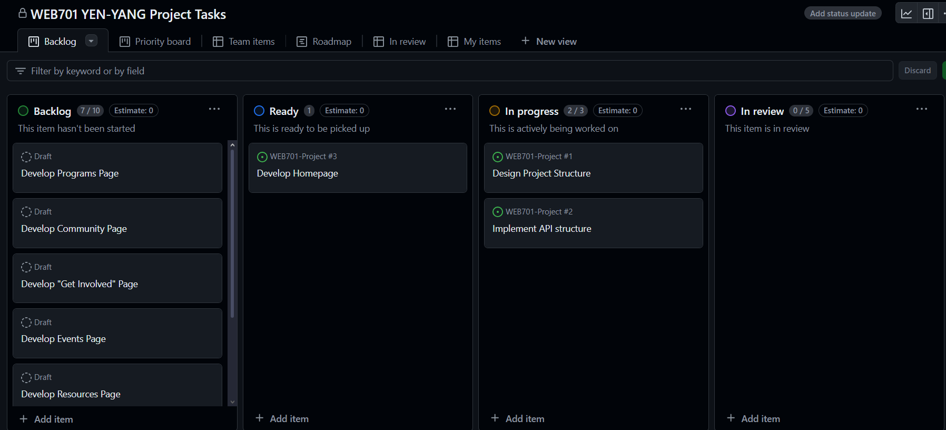

### CRUD analysis – API prototype

Produce a CRUD table – details to come, that lists the proposed INSERTS (creates), RETRIEVALS, UPDATES and DELETIONS of data required in the implementation of your website.

C = Create R = Read U = Update D = Delete

|  |  |  |  |  |  |
| --- | --- | --- | --- | --- | --- |
| Process | Username | First Name | Last Name | Email | Password |
| Make an account | C | C | C | C | C |
| Login to Account | R | R | R | R | R |
| Delete Account | R , D | R, D | R, D | R, D | R, D |
| Update Account | R, U | R, U | R, U | R, U | R |

# Evaluating web technology – which to use.?

# Developing the website – about web technology

# Summary and Conclusion

# References

APA 7 style citations and references throughout this report.